East West University Center for Research and Training (EWUCRT)
EWUCRT Research Proposal Form

Note:
- You can expand each box, given below, if necessary.
- Provide necessary citations and references based on relevant EWUCRT guidelines (see below).
- Before filling out this form, please carefully read the EWUCRT guideline for writing a research proposal. The guideline can be downloaded from the link: https://www.ewubd.edu/notice-details/call-research-proposal-round-17

A. Research Title:
Title of proposed research:

- The title of the research proposal must be concise and clear.

B. Researcher’s Details:
- Principal researcher’s details:
  - Name:
  - Designation:
  - Department:
  - Address:
  - Phone
  - Email:

- Co- researcher(s) details:
  - Name:
  - Designation:
  - Department:
  - Address:
  - Phone
  - Email:

C. Executive Summary of the Research Proposal/ Abstract:
- Maximum 500 words.

D. Detailed Research Proposal:
D1. Introduction/ Background/ Problem Statement
- At least 750 words.

D2. Literature Review
- At least 750 words.

D3. Significance of the Research
- At least 50 words.

D4. Research Objectives
Hints:
- Research objectives must be clearly delineated as they are different from hypothesis.
- Study objectives usually refer to the specific aims of the study and should be clear. A researcher may have multiple hypotheses to achieve an objective.

- At least 50 words.
- Please specify which SDG goals your research will explore?

D5. Hypothesis
Hints:
- Hypothesis proposes a causal linkage between dependent and independent variables.
- Hypothesis must be derived from the existing theoretical framework/ literature review.
- A research hypothesis is a testable proposition or predictive statement about the possible outcome of a scientific research study.

- At least 50 words.

D6. Research Methodology
- At least 500 words.
- Please state the procedures and techniques that you will use to collect the data.
- Sampling methods and selection of sample size must be well justified.
- The data analysis process and analytical framework should be well defined.

D7. Expected Outcomes of the Research, if Relevant e.g. Novel Theories/ New Findings/ Knowledge Invention/ Innovation
- At least 50 words.

D8. Ethical Concern
- At least 50 words.

D9. Limitations of the Study
- At least 50 words.

D10. References
- At least 10 references.
- Latest references should be used (preferably after 2020).

E. Milestones and Time Frame
- Please set the milestones of your research activities and prepare a Gantt chart according to your milestones (See the appendix-A for sample Gantt chart).

F. Budget

F1. Description of Budget
Description | Total Amount  (in Taka) | Breakdown of Expenses | Installment  (One) | Installment  (Two)
1. Compensation for Research Assistant
2. Compensation for Data Entry
3.Conveyance and Communication
4. Stationary items (if applicable)
5. Training of Supervisor/ enumerator of Survey
6.Data Collection Cost
1
2
3
4
5
6
7. Other recurrent cost(s)
8. Research report production cost
Total
F1. Justification of Budget
Description | Breakdown of budget  (Person-month @ Taka) | Justification
1. Compensation for Research Assistant
2. Compensation for data entry
3.Conveyance and communication
4. Stationary items (if applicable)
5. Training of Supervisor/ enumerator of Survey
6.Data collection cost
1
2
3
4
5
6
7. Other recurrent cost(s)
8. Research report production cost
Total

G. Declaration by the Principal Researcher:

I hereby declare that all information stated herein is true. The EWUCRT has the right to reject or withdraw the application without prior notice.

Date: Signature of Principal Researcher

Appendix-A
Milestones | Activities | Year/ Month
 |  | Jan | Feb | Mar | Apr | May | Jun | Jul | Aug | Sep | Oct | Nov | Dec
1 | Literature review
2 | Questionnaire/ tools and technique development
3 | Data collection
4 | Data analysis
5 | Draft report
6 | Draft report presentation
7 | Final report submission

Appendix-B
Application Flowchart

Appendix-C
Monitoring Flowchart
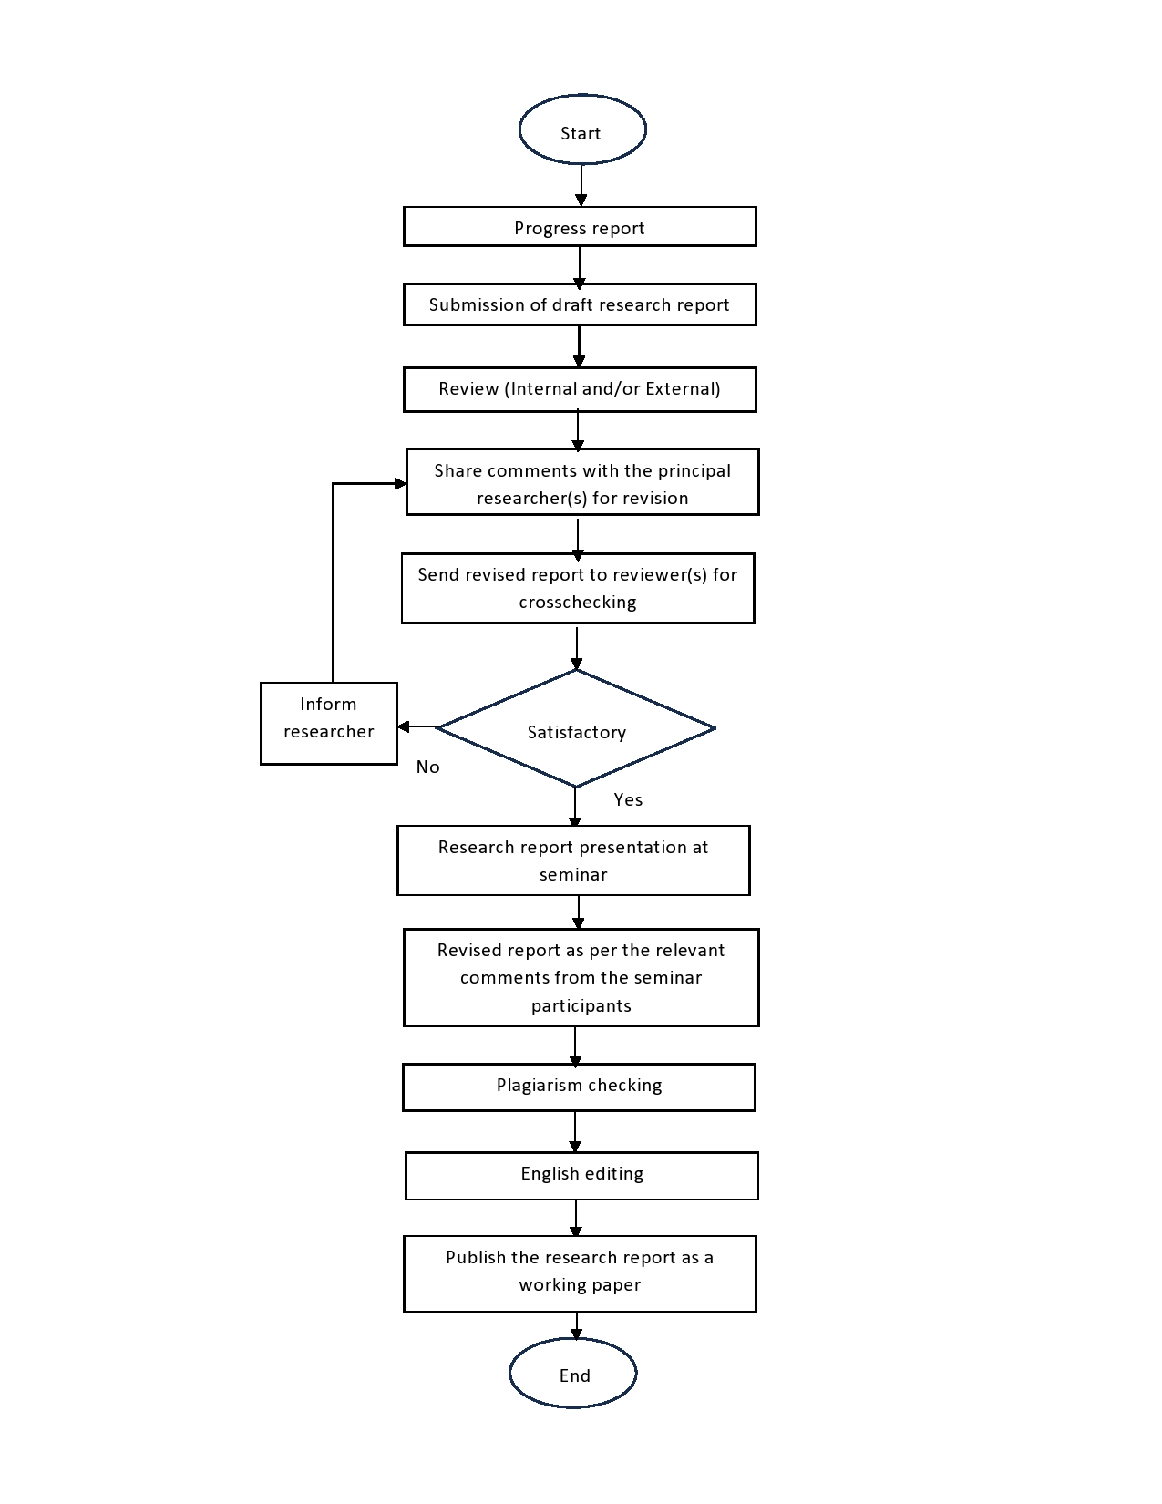

Please look at our existing equipment list by contacting Mr. Riyad Khandaker, Senior Lab Officer, EWUCRT, Ext. 452 or by sending an email to ewucrt@ewubd.edu, before requesting research equipment. You are also requested to provide specifications of all research equipment in description column.

