**Oils, Fats and Waxes­­­**

**Fats, oil and waxes:**

A group of naturally occurring compound called as Lipids/Lipids are the substances of animal or plant origin and comprise of fixed oils, fats and waxes.

**Fats and oils:**

Fats and oils are esters composed of three fatty acid units joined to glycerol (trihydroxy alcohol), thus called triglycerides.

* most abundant lipids in nature
* provide energy for living organisms,
* insulate body organs,
* transport fat-soluble vitamins through the blood.

**Waxes**

Waxes are esters of numbered monohydric primary alcohol.

**# Compositions of Fats and Oils**

*Fatty acid,* a carboxylic acid with a long aliphatic chain. The fatty acids of natural fats have 4 to 24 carbon atoms. These fatty acids may be saturated, monounsaturated, polyunsaturated.

*Glycerol,* a simple polyol compound/a trihydroxy alcohol (propane-1,2,3-triol), which has three hydroxyl groups.

Fats and oils are called *triglycerides*, esters of glycerol.

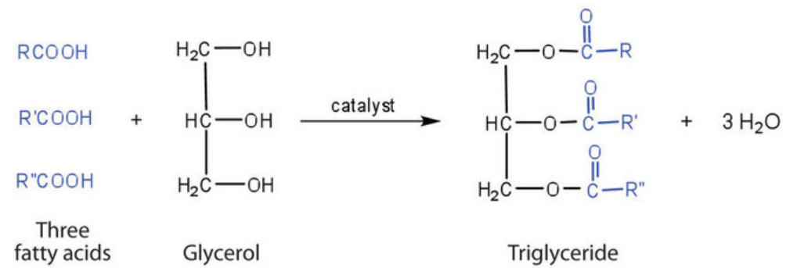

where R, R', and R" are long alkyl chains; the three fatty acids can be all different, all the same, or only two the same.

If all three OH groups on the glycerol molecule are esterified with the same fatty acid, the resulting ester is called a simple triglyceride. Although simple triglycerides have been synthesized in the laboratory, they rarely occur in nature. Instead, a typical triglyceride obtained from naturally occurring fats and oils contains two or three different fatty acid components and is thus termed a mixed triglyceride.

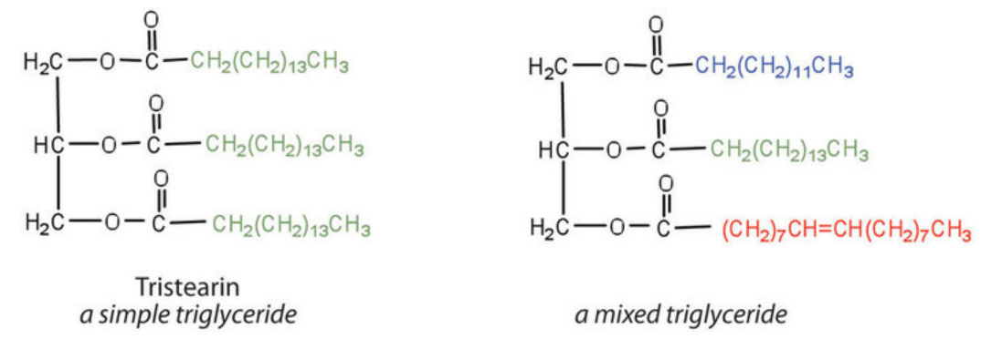

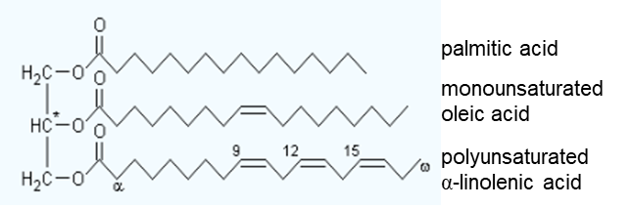

*A triglyceride, overall unsaturated, with the glycerol backbone*

A triglyceride is called a fat if it is a solid at 25°C; it is called an oil if it is a liquid at that temperature. These differences in melting points reflect differences in the degree of unsaturation and number of carbon atoms in the constituent fatty acids. When degree of unsaturation is more, the compounds tends to be in lipid state and is referred to as oil, while those with low degree of unsaturation are solids and are referred to as fats. Thus the fatty acid composition of the triglycerides determines whether a substance is a fat or oil.

*Q. Which of these triglycerides are present in higher amounts in fats?*

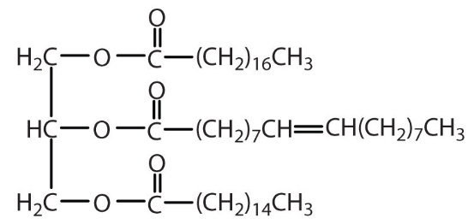 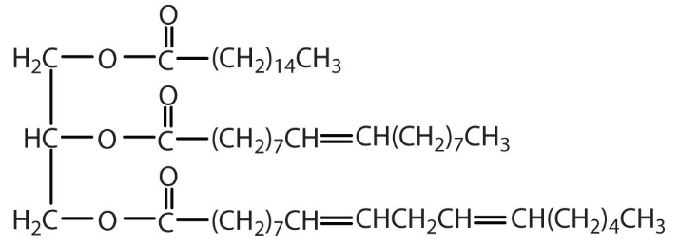

1st triglyceride, because it is composed of a greater number of saturated fatty acids. It is expected to be present in higher amounts in fats. 2nd triglyceride is composed of a greater number of unsaturated fatty acids and found in oils.

**# Difference between fats, waxes and oils**

|  |  |  |
| --- | --- | --- |
| Fats | Oils | Waxes |
| Esters of saturated fatty acids | Esters of unsaturated fatty acids | Esters of monohydric primary alcohol |
| On hydrolysis yield a long chain fatty acids and glycerol. | On hydrolysis yield a long chain fatty acids and glycerol. | On hydrolysis yield a long chain fatty acid and a long chain monohydric alcohol. |
| Solid at room temperature | Liquid at room temperature | Solid at room temperature |

**# Classification of Fats & oils**

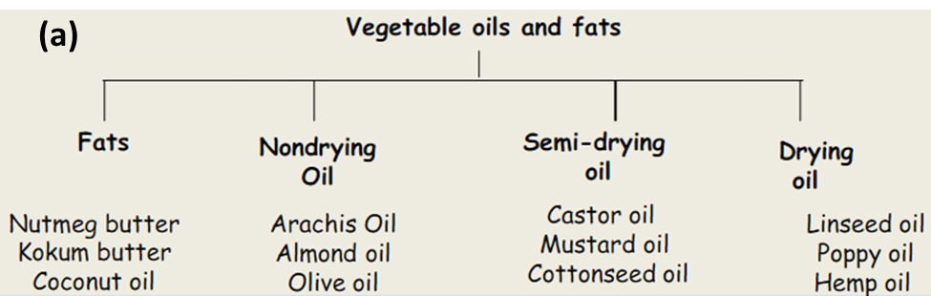

*Non-drying oil*, an oil which does not harden when it is exposed to air.

*Semi-drying oil*, an oil which partially hardens when it is exposed to air.

*Drying oil*, an oil that hardens to a tough, solid film after a period of exposure to air.

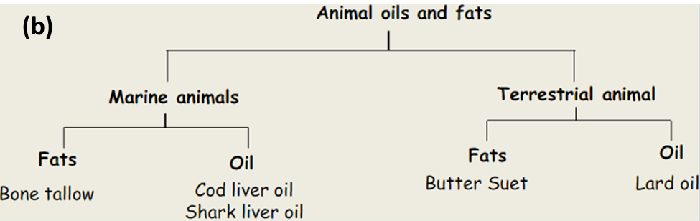

**# Chemical Properties of Fats and Oils**

1. Hydrolysis:

Fats and oils can be hydrolyzed in the presence of an acid, a base, or specific enzymes. The hydrolysis of fats and oils in the presence of a base (sodium carbonate or sodium hydroxide) is used to make soap using water under high pressure and temperature and is called saponification.

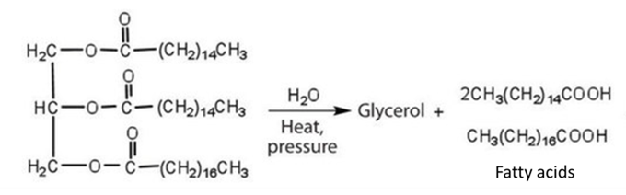

Free fatty acids react with alkali to form soaps as follows:

R-COOH + NaOH -> R-COONa + H2O

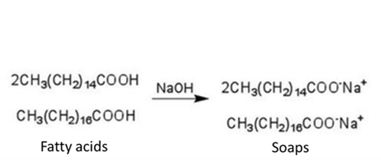

The sodium soaps formed are water soluble enough to be separated from the oil or fat as an aqueous solution.

1. Hydrogenation:

Natural vegetable oils and fats contain unsaturated acids in the cis form. Vegetable oils and fats are almost trans free (below detection limit in seeds). Trans fatty acids occur in most animal fats, e.g., in butterfat at a level of 2.545%.

* The double bonds in oil can undergo hydrogenation. Hydrogenation increases the oil’s saturated fat content. Generally, triglycerides with more unsaturated fatty acid substituents are more healthful. Unsaturated fats have kinks in their molecular structures that reduce the tendency for them to cause clogged arteries and reduce the tendency to pack efficiently and form solids. In contrary to unsaturated fats, saturated fats have more linear fatty acid chains that pack well and solidify easily, thus causing cause clogged arteries. In commercial processes, the number of double bonds that are hydrogenated is carefully controlled to produce fats with the desired consistency (soft and pliable).

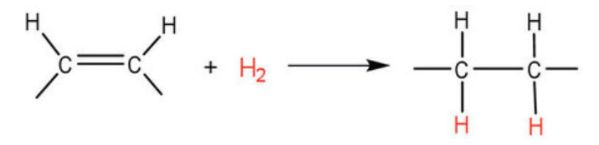

* Double bonds in the fatty acids of vegetable oils subjected to the high temperatures (around 150°C) during hardening or frying can also undergo isomerization from the cis to trans configuration. Thus during partial hydrogenation of vegetable oils, an isomerization reaction occurs that produces the trans fatty acids. Trans-fatty acids have structures like saturated fats and do not have the bend in their structures, thus pack closely together in the same way that the saturated fatty acids do. When consumed, these compete with the natural all-cis isomers for metabolism and indeed could interfere with the normal metabolism of polyunsaturated fatty acids with potentially harmful effects. Consequently, trans fatty acids are unhealthy, raise cholesterol levels and increase the incidence of heart disease.

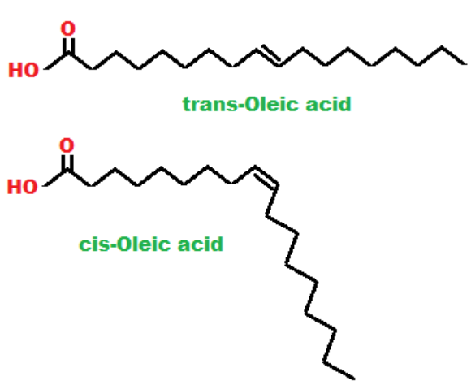

Vegetable oils (canola, corn, soybean) are thus transformed into margarine and cooking fats. Margarine is a processed food that is designed to taste and look similar to butter. It is often recommended as a heart-healthy replacement. Modern types of margarine are made from vegetable oils, which contain polyunsaturated fats that can lower the "bad" LDL cholesterol when used instead of saturated fat.

A more recent process called interesterification achieves similar results without forming any trans fats [Ref: Nutr Bull. 2017 Jun; 42(2): 153–158]. In this process, the fatty acids have been moved from one triglyceride molecule to another.

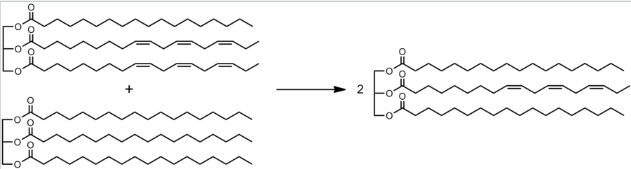

Figure: A triglyceride with two Polyunsaturated fatty acids (linolenic acid) residues and a saturated one undergo interesterification toward two molecules containing one PUFA residue each.

1. Oxidation:

Fats and oils undergo oxidation if contact with moist air at room temperature, then hydrolysis reactions cause them to turn rancid, acquiring a characteristic disagreeable odor. Thus, release of volatile fatty acids by hydrolysis of the ester bonds can cause this disagreeable odor and cause *hydrolytic rancidity*. Short-chain fatty acids, such as butyric acid, have unpleasant odor. For example, Butter, releases foul-smelling butyric, caprylic, and capric acids.

*Microbial rancidity* refers to a process in which microorganisms present in the air, such as bacteria or molds, use their enzymes such as lipases to break down fat.

*Oxidative rancidity* is associated with the degradation by oxygen in the air. The double bonds of an unsaturated fatty acid can be cleaved by free-radical reactions involving molecular oxygen. This reaction causes the release of malodorous and highly volatile aldehydes and ketones. One particularly offensive product, formed by the oxidative cleavage of both double bonds in this unit, is a compound called malonaldehyde.

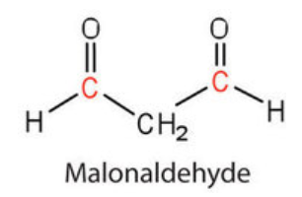

Mechanism: A chemical attack on the alkyl group is followed by a chain reaction, resulting in a hydroperoxide group (-OOH) in the chain. The steps are as follows:

1. The chain reaction is started by peroxy-, alkoxy- and alkyl-radicals
2. The chain reaction proceeds by reaction with oxygen or RH
3. It is accelerated by branching of the chain

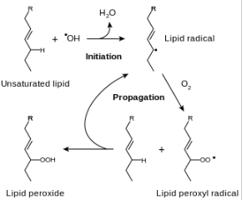

Figure: The free radical pathway for the first phase of the oxidative rancidification of fats.

The hydro peroxides formed react further to aldehydes, ketones and fatty acids. Highly unsaturated oils are especially susceptible to this type of reaction.

Prevention of rancidity/oxidation:

1. Hydrolytic rancidity can easily be prevented by covering the fat or oil and keeping it in a refrigerator.
2. Sterilization can reduce microbial rancidity. Antimicrobial agents can also prevent rancidification by inhibiting the growth of bacteria or other micro-organisms that affect the process.
3. Oxidative rancidity can be prevented by light-proof packaging, oxygen-free atmosphere (air-tight containers) and by the addition of antioxidants. Oxygen scavenging technology can be used to remove oxygen from food packaging and therefore prevent oxidative rancidification.

**Antioxidants** are the substances often used as preservatives in fat-containing foods in very small amounts (0.001%–0.01%) to delay the onset or slow the development of rancidity due to oxidation. Antioxidants are compounds whose affinity for oxygen is greater than that of the lipids in the food; thus they function by preferentially depleting the supply of oxygen absorbed into the product. Natural antioxidants include ascorbic acid (vitamin C) and tocopherols (vitamin E). Synthetic antioxidants include butylated hydroxyanisole (BHA), butylated hydroxytoluene (BHT), TBHQ, propyl gallate and ethoxyquin. The natural antioxidants tend to be short-lived, so synthetic antioxidants (such as Propyl Galate) are used when a longer shelf-life is preferred.

1. Polymerization

If fats and oils are heated above 250'C and kept at that temperature, the probability of fatty acid dimerization (intermolecular) or cyclization (intramolecular) increases. If oil is kept for an extended period in an open atmosphere at high temperature (e.g., deep frying), oxidative polymerization can occur, as indicated by a deeper color and increased viscosity. In oxidative polymerization, fatty acid molecules are intramolecularly or intermolecularly bound via an oxygen bridge. Splitting off oxygen can lead to cyclization, dimerization and polymerization. Polymerization is technologically used only for oils that are not intended for edible purposes. Tung oil, for example, is polymerized by being kept at 300°C for 12 min; a cross-linked polymer is formed.

The "drying", hardening, or, more properly, curing of oils is the result of autoxidation, the addition of oxygen to an organic compound and the subsequent crosslinking. This process begins with an oxygen molecule (O2) in the air inserting into carbon-hydrogen (C-H) bonds adjacent to one of the double bonds within the unsaturated fatty acid. The resulting hydroperoxides are susceptible to crosslinking reactions. Bonds form between neighboring fatty acid chains, resulting in a polymer network, often visible by formation of a skin-like film on samples. This polymerization results in stable films that, while somewhat elastic, do not flow or deform readily.

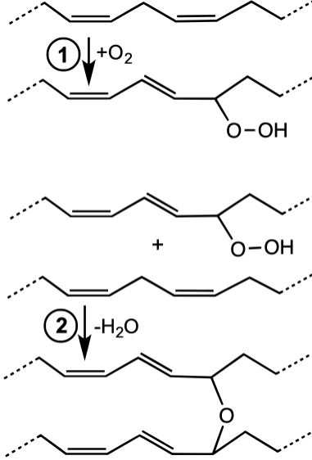 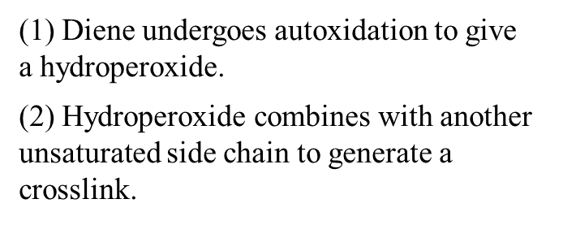

Figure: Chemical reactions associated with drying process in Diene-containing fatty acid derivative