**Oils, Fats and Waxes (part 2)**

One unsaturated fatty acid is ubiquitous in fats and oils; two are almost ubiquitous. Oleic acid is present in all known fats and oils. Almost all fats and oils contain its next lower homologues, palmitoleic acid (although in very small quantities) and the double unsaturated acid with the same chain length as oleic acid, namely, linoleic acid, as well as other C18:2 acids.

**# Saturated fatty acids:**

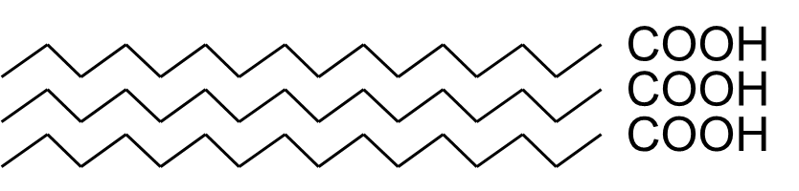

Properties of Saturated Fatty Acids:

* Contain only single C–C bonds
* Closely packed, Fit closely in regular pattern
* Strong attractions between chains
* High melting points
* Solids at room temperature

List of saturated Fatty Acids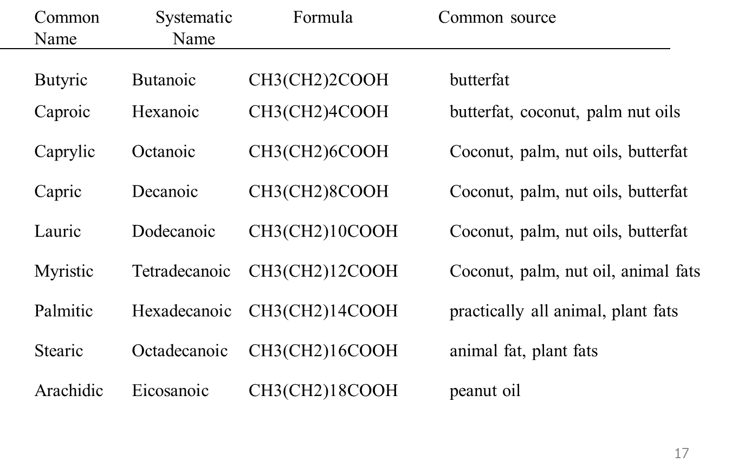:

**# Unsaturated fatty acids:**

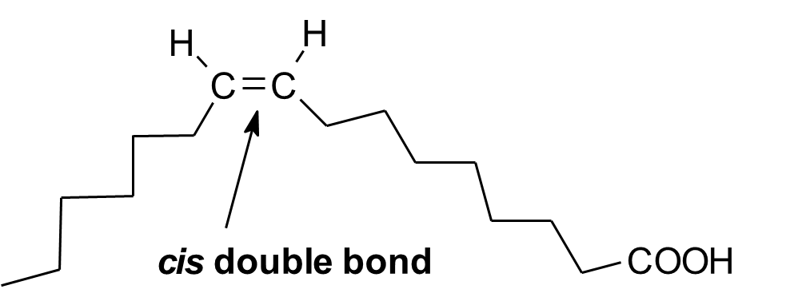

Properties of Unsaturated Fatty Acids:

* Contain one or more double C=C bonds
* Nonlinear chains do not allow molecules to pack closely
* Few interactions between chains
* Low melting points
* Liquids at room temperature

List of Unsaturated Fatty Acids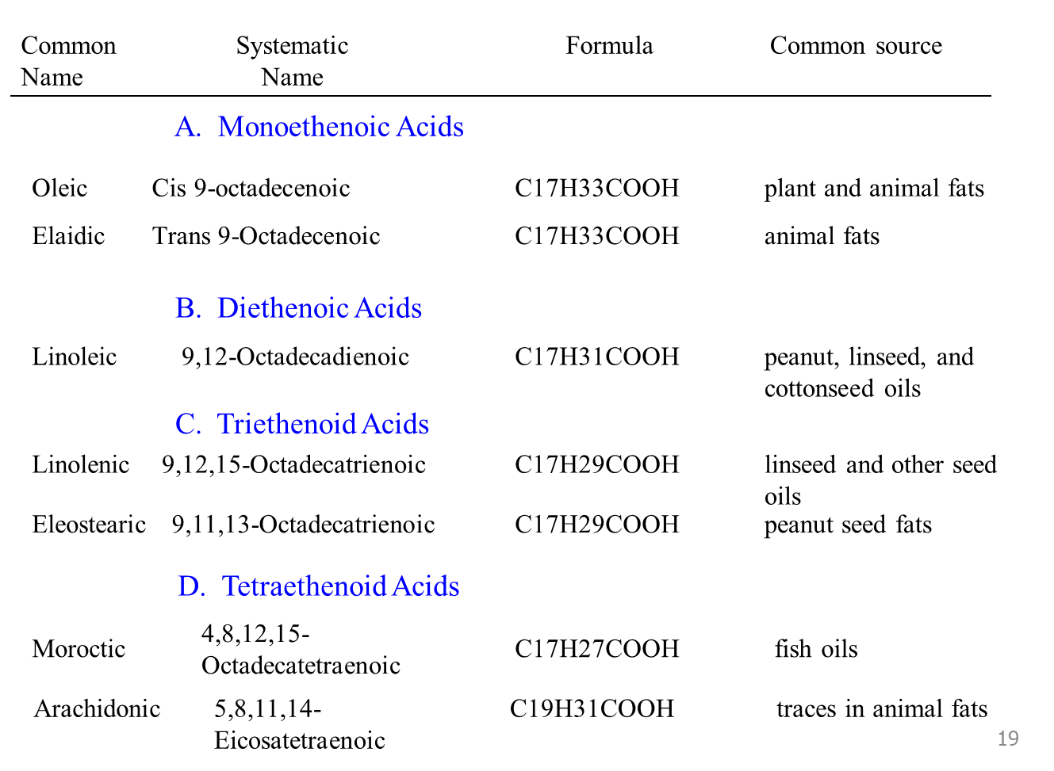:

**#Fatty Acid Distribution of Common Vegetable Fats/Oils:**

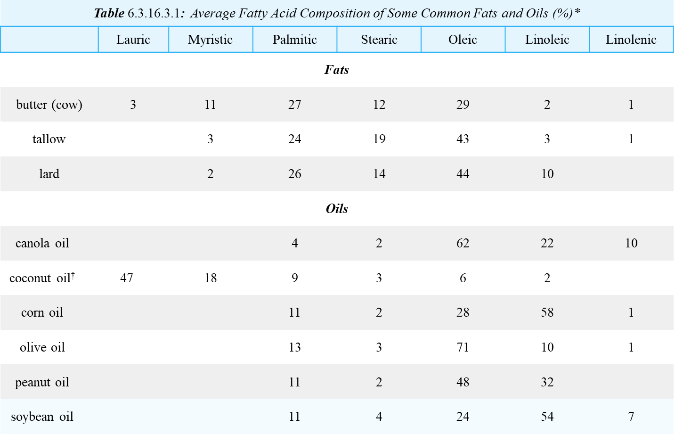

**# Properties of fats and oils:**

1. Pure fats and oils are colorless, odorless, and tasteless. The characteristic colors, odors, and flavors that we associate with some of them are imparted by foreign substances that are lipid soluble and have been absorbed by these lipids. For example, the yellow color of butter is due to the presence of the pigment carotene; the taste of butter comes from two compounds—diacetyl and 3-hydroxy-2-butanone—produced by bacteria in the ripening cream from which the butter is made.

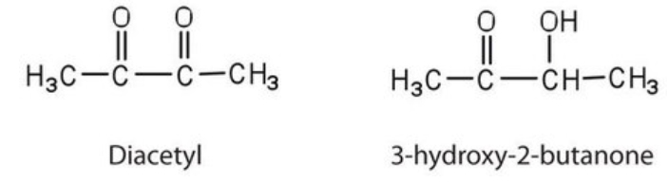

1. Fats and oils are lighter than water, having densities of about 0.8 g/cm3. Fats have a density of 0.91-0.95 cm3/g, a very low vapor pressure and consequently, a very high boiling point. The melting point of oils usually lies below 0° C.
2. They are poor conductors of heat and electricity and therefore serve as excellent insulators for the body, slowing the loss of heat through the skin.
3. Fats and oils are soluble in nonpolar solvents and chlorinated hydrocarbons.
4. Degree of unsaturation of fatty acids present in oils and fats; this property can be changed by hardening.
5. Distribution of the 10-12 main fatty acids over the three different positions of the glycerol molecule.
6. The main chemical reactions that occur naturally are saponification and oxidation.

The important properties to be considered are: melting points and degree of unsaturation from component fatty acids.

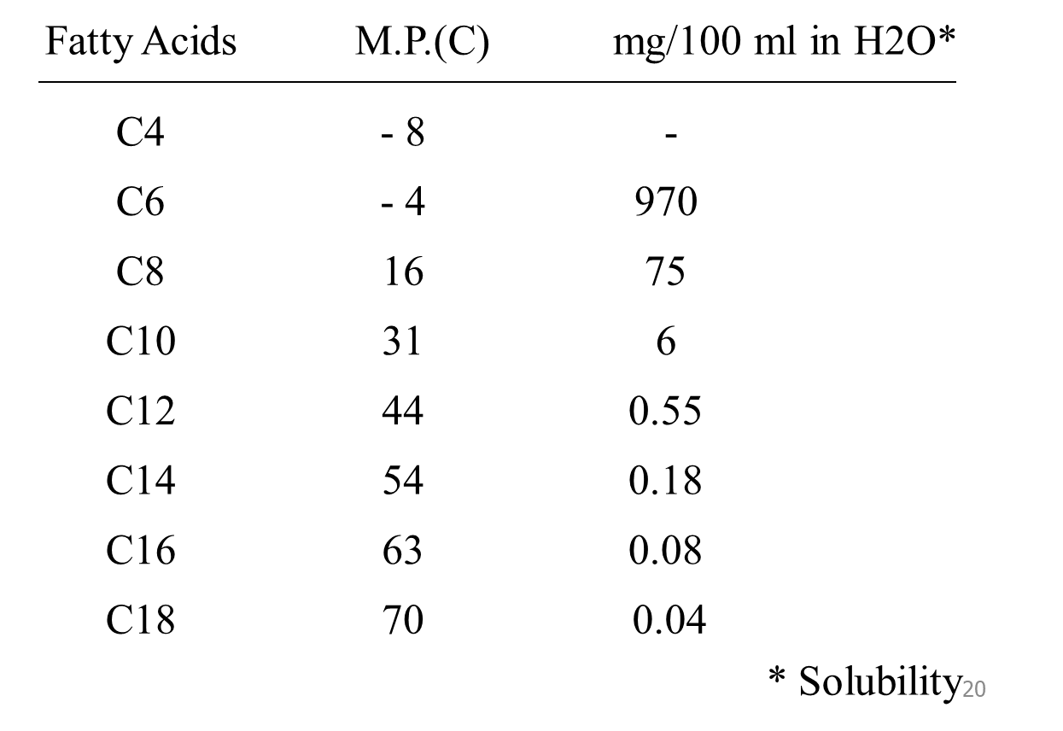

*Effects of Double Bonds on the Melting Points*

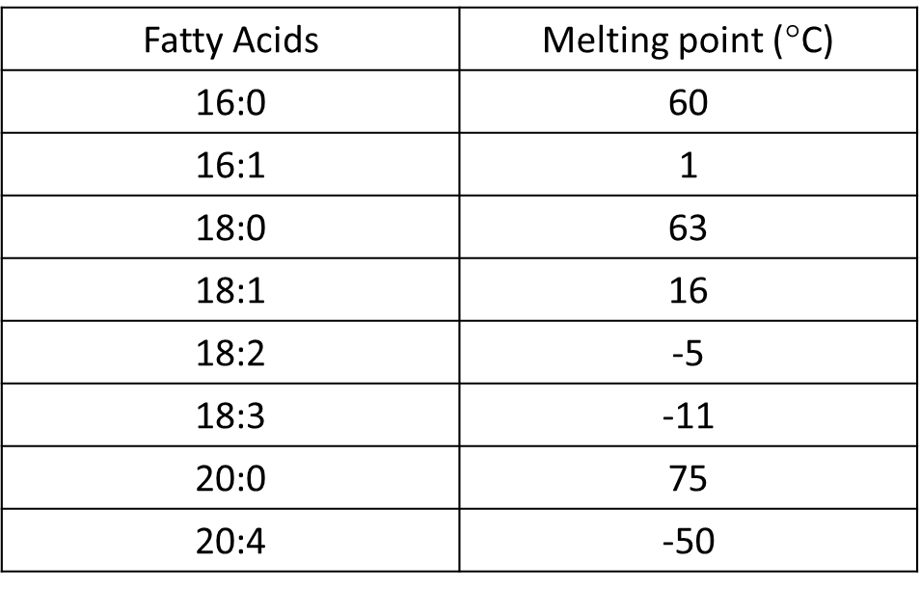 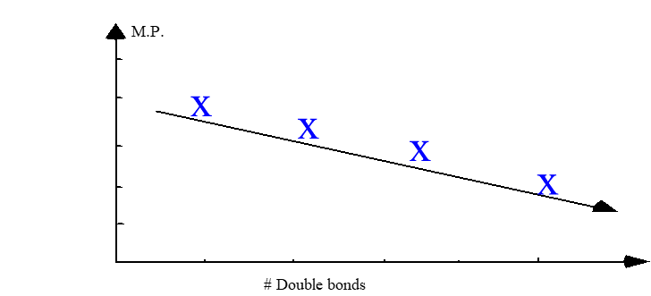

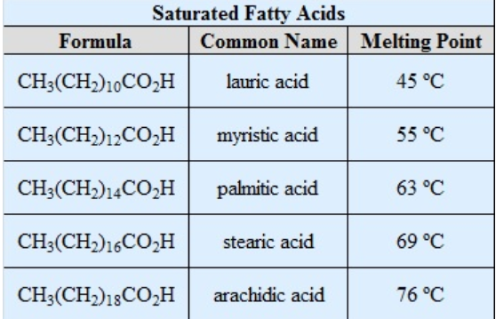

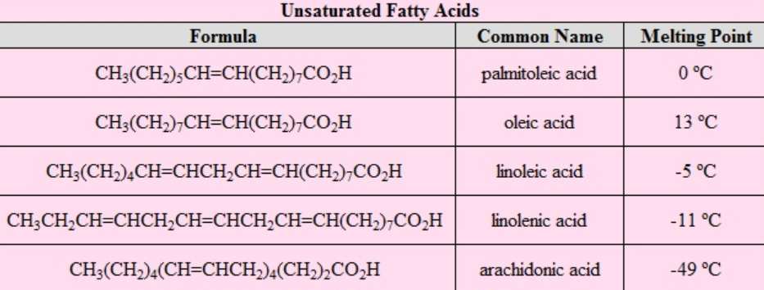

The higher the melting points, the higher the saturation in fatty acid content. The higher melting points of the saturated fatty acids reflect the uniform rod-like shape of their molecules. The cis-double bond(s) in the unsaturated fatty acids introduce a kink (a sharp twist or curve) in their shape, which makes it more difficult to pack their molecules together in a stable repeating array or crystalline lattice. The trans-double bond isomer of oleic acid, known as elaidic acid, has a linear shape and a melting point of 45 ºC (32 ºC higher than its cis isomer). The shapes of stearic and oleic acids are displayed in the models below. Thus, the melting points of triglycerides reflect their composition, as shown by the following examples. Natural mixed triglycerides have somewhat lower melting points, the melting point of lard being near 30 º C, whereas olive oil melts near -6 º C. 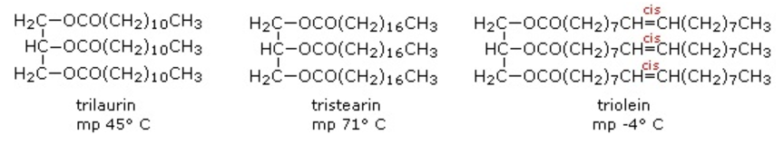

**# Non-drying, semi-drying and drying oils**

* based on the ease of autoxidation and polymerization of oils (important in paints and varnishes)
* the more unsaturation in the oil, the more likely the “drying” process
  + - Non-drying oils: Castor, olive, peanut, rapeseed oils
    - Semi-drying oils: Corn, sesame, cottonseed oils
    - Drying oils: Soybean, sunflower, hemp, linseed, tung, oiticica oils

Increased degree of unsaturation means the product will be less stable and may need protection from light, oxygen. In general, higher is the unsaturation and hence higher is the chances of oxidation upon exposure to atmosphere (i.e., rancidity tendency increases). so, it reduces the self-life of an oil. Such oils are dying oils, used in paint/varnishes as they can dry easily. (e.g., linseed oil, iodine value is roughly lies between 130-140).

The self-life of non-drying oil is more. Usually used for soap manufacturing. Non-drying oils have 1 double bond and semi drying oils contain some proportion of double.

**Exercise 1:** How would the melting point of stearic acid compare to the melting points of oleic acid and linoleic acid? Assign the melting points of –17° C, 13° C, and 69° C to the correct fatty acid. Explain.

**Answer:** Stearic acid is saturated and would have a higher melting point than the unsaturated fatty acids. Because linoleic has two double bonds, it would have a lower mp than oleic acid, which has one double bond.

stearic acid mp 69° C, oleic acid mp 13° C, linoleic acid mp -17° C

**Exercise 2:** What are the fatty acids in the following triglyceride?

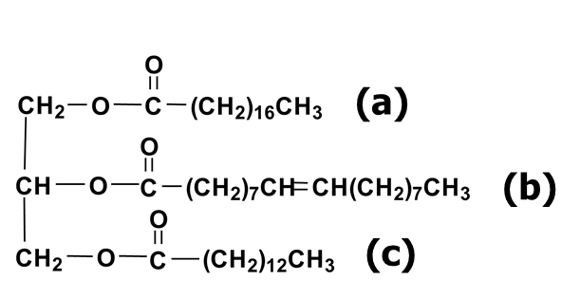

**Answer:** (a) Stearic acid; (b) Oleic acid; (c) Myristic acid

**Exercise 3:** What are the products obtained from the complete hydrogenation of glyceryl trioleate?

**Answer:** Glyceryltristearate